Chakra FAQs

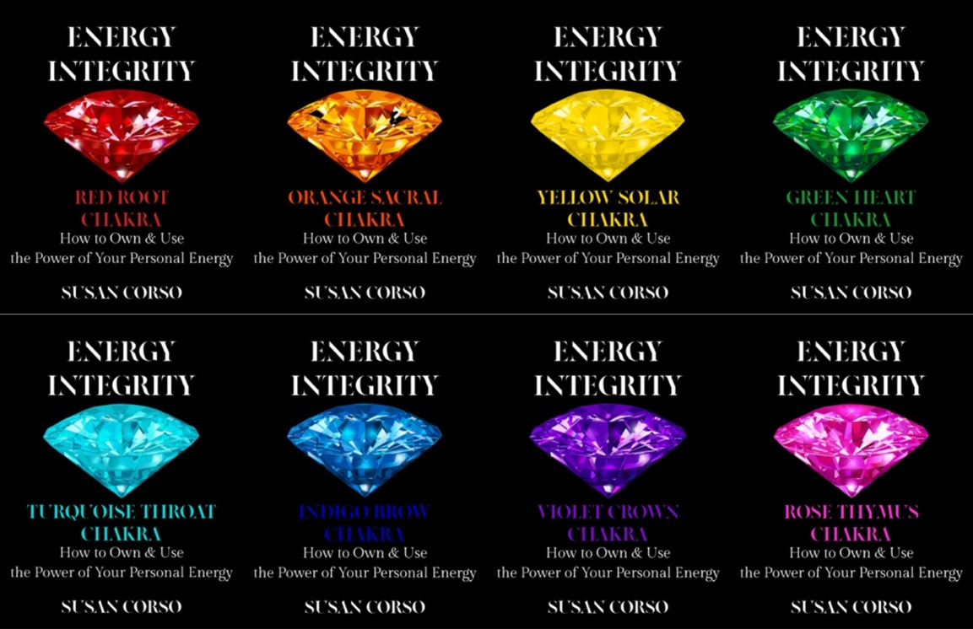

ChakraFAQs from the iampersand.org website

You have been a spiritual counselor for over forty years. How and why are you focusing on the human energy system now, and why by way of chakras?

Because a lot of humans are completely stressed out, exhausted, downright weary, and have no idea whether they even can regenerate their own depleted energies, let alone how. We aren’t taught how to work with our own bodies. Or even that we can work with our bodies. The chakras are the gateway to the human energy system.

In my experience working with clients, few even know that there is such a thing as a human energy system, let alone that we each have one, and that we can learn to work with it to manage stress, to heal, to grow, to regenerate, and to thrive. Chakras give you access to your own natural integrity—your inherent wholeness.

What is the human energy system, and how are chakras a part of it?

When a person goes to medical school, they study eleven bodily systems. You know, the circulatory, the skeletal, the digestive, those. None of them, or it’s a rare doctor who, asks what actually animates those systems. It’s life force, sometimes called chi, or prana, or mana. From my experience, there is a Divine Spark in everyone that makes all those other systems function. Chakras are that spark, viewed through a prism so we can see all its parts.

How many people do you think that you’ve helped using chakras over the years?

Thousands. I’ve had my own private practice, and I was the head of spiritual and energy medicine for a big healthcare concern in Boston. I use the chakras as a barometer of truth with a client. Chakras, much like bodies themselves, are very cool. They don’t lie, but they don’t lie because they can’t lie. Everyone can learn how to connect to the truth of their own chakras, and how to read the information they provide. There are physical sensations connected to chakras if we’ll get still and attend to them. Those sensations can provide invaluable information.

Aren’t the chakras an esoteric religious teaching? What do they have to offer modern Westerners?

Yes, chakras are part of Eastern modalities. They go along with acupuncture meridians, and Ayurvedic nadis. Centers of energy in the body have been identified by healers and shamans throughout time. What they offer Westerners is access to information about ourselves from the inside-out, not the outside-in.

We in the West are so focused outwardly that our inner worlds are often neglected. It’s one of the reasons there’s so much systemic illness. Our bodies, wondrous and wise as they are, give us invaluable information if we’ll pay attention to it. That mandates an inner focus. It also asks for silence, and stillness. The addiction to busyness prevents us from being true to ourselves.

Are you saying that we don’t need doctors or therapists if we practice this energy work?

No, I’m saying that our awareness of our inner states will help us utilize both kinds of professionals more effectively. Chakras can confirm and deny what you hear from outside you. I’ve seen a session of chakra work—one!—make ten years of therapy suddenly click for a client who despaired of it ever making sense. I’ve also seen chakra work invalidate the work of a medical intuitive and save someone’s life. Energy work is just one more way to understand yourself, and I believe that self-understanding leads to understanding others better, and only good can come of that. Look around; it’s something we’re sorely missing right now.

How do we use chakras to manage our energy system? Can you give us an example of what that might look like in everyday life?

First, it’s good to learn about chakras, to know they’re there, and that you can access them.

Second, it’s good to connect to your chakras regularly, and keep in touch with what’s going on inside you, as well as outside you.

Third, it’s good to know your chakras as they are now, so you can be aware of how or if they change.

Fourth, it’s good to be able to check in with your chakras, knowing that they’ll tell you the truth every time.

I have a daily chakra practice that I do when I waken in the mornings. I lie still, and reach inward with my mind to be sure all my chakras are connected. I focus on each one and make sure their colors blend gently and easily. If one doesn’t, I stop and inquire about what’s going on. Perhaps someone hurt my feelings and I stuffed it. Or I need to ask someone’s forgiveness. Or any number of flags on the field. I let my chakras lead my behavior. It can make life much more efficient.

What would you say to a skeptic about chakras?

I’d quote Hamlet. “There are more things in heaven and Earth, Horatio, than are dreamt of in your philosophy.” I welcome skeptics mostly because within a few queries, I can prove to them there is such a thing as energy. We’re steeped in it, all the time. Every one of us has walked into a room and just known there’s been recent anger in it. It makes us just want to turn around and leave. That’s energy. If I run my hand above an open palm, I can interrupt the energy of the person whose palm it is. That’s energy. Not only that, but almost all of us has the experience of following our gut instincts. That, too, is energy.

The cool thing is, there’s no downside to working with your own energy system. I tell skeptics to try it. If it works, great. If it doesn’t, no harm, no foul. The other thing is: working with chakras costs you nothing. You don’t need a place to go to do it, you don’t need special clothes to do it, you don’t need a teacher to do it. You need focus, commitment, time to yourself, and the willingness to pay attention.

What is a chakra detective, and how do I become one?

Chakra detective is the somewhat whimsical name I give to those of us who work with the human energy system. I’m a mystery writer in another part of my life, and my investigator uses energy to solve her cases. Chakras, no matter that they form a system, are mysterious. There is no one set of chakras like any other. How they work together is unique to each individual. Sure, there are guidelines, but even those can be bent or changed, depending upon the life experiences of the person. You become a chakra detective by working with your own system, slowly but surely learning as you go.

Can I do this work to help other people?

Well, I do, but I’ve been doing it for a long, long time. Can you help others immediately? Yes, by sharing what you’ve learned about your own chakra system, but can you work in someone else’s chakra system to help them? No, not immediately. Or, not without risk that I would not recommend. By all means, get yourself a chakra buddy, and share what you’re learning, but Physician, heal thyself. Start close to home, and then branch out.

Sometimes, I take apprentices, and teach people to do this. The best way to reach me is through the contact forms on my websites. Reach out, and tell me of your interest.

Twice a year, I take an elite group of six students through intensive training in the methods I’ve developed for working with the chakras. Go to my website for details about dates.

You write novels as well as spiritual nonfiction. Do you ever write about chakras/the human energy system in your novels?

All the time! All of my characters are sensitive to energy in various ways. The protagonist in The Mex Mysteries is an intuitive investigator—she follows the energy to solve her cases. There’s an intuitive in The Boots & Boas Romances, as well as a hugely skeptical cop who is often surprised by what the energy reveals. In my newest series, The Subversive Lovelies, one of the sisters is a metaphysician; she uses energy in all her work.

At some point, I’ve been thinking that I ought to structure a whole book based on the chakra system—probably a mystery. We’ll see. To find out more, visit my fiction website.

What sets your chakra work apart from others teaching about chakras?

I’m sure you can imagine that I’ve done a lot of reading about chakras in forty years. Mostly, I find that chakra teaching is made complicated and mysterious by teachers. My chakra workbooks, Energy Integrity, include teaching, yes, but mostly it’s a system whereby anyone can learn to access and use the information encoded in their own chakras through its application. I envision the chakra system and how to work with it simply enough that, at their own level, even children can learn to use it. I consider this information fundamental enough that it ought to be taught as basically as hygiene.

Who’s the ideal person for these workbooks? Who did you write these workbooks for?

I wrote these workbooks for anyone who wants to learn to regenerate themselves, for anyone who is tired of feeling stressed out, for anyone who has undiagnosable symptoms, for anyone who wants to understand themselves that much more than they already do.

You know, a recent Harris Poll says that the number one stressor for Westerners right now is money. That’s not a particular surprise—money can be stressful—but who do you call on for help with your stress around money? You don’t go to the doctor for it. Or a therapist. This chakra work, applied diligently and deliberately, can ease these sorts of things.

Where do I get these workbooks?

If you live in the US or the UK, Exclusively at Amazon.com, They’re workbooks, so they’re print books. And for those to whom amazon does not make available the print versions, the pdfs are available for purchase in the emporium on my website here.

Do you still work with people one-on-one using chakras?

I do still take clients. The best way to reach me is through the Contact Form on my website.

